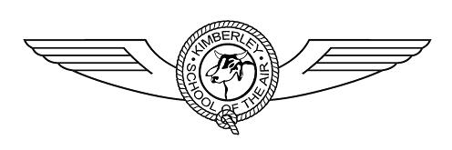
“Together in Isolation”
ABN 82 433 875 430

PMB 988 Derby WA 6728
Telephone: (08) 9193 1006 Fax: (08) 9191 1539 E-mail: Paul.Noble@education.wa.edu.au
http://www.ksota.wa.edu.au/

Welcome to Kimberley School of the Air. Please find enclosed the enrolment package.

Please complete the enrolment form (one for each child), family profile and return them to this office as soon as possible. We would also require you to send a photocopy of your child’s birth certificate and immunization information.

Please also read the enclosed ‘Enrolment Guidelines’ carefully. They describe your obligations and responsibilities upon enrolment.

Learning resources will be sent to you upon receipt of your enrolment forms. Teachers will also be in contact with you as soon as possible to assist you with your introduction to correspondence learning.

Please don’t hesitate to contact us at any time.

The FREECALL number for Kimberley School of the Air is 1800 816 212.

From the Principal and all of the staff at KSOTA, welcome to our school!

Yours sincerely

Paul Noble
PRINCIPAL

